 

Bar & patio

AVAILABLE DAILY 4-7pm

*Bar and outside only

**COCKTAILS $10**

**PAMPLEMOUSSE SPRITZ**

*vodka, elderflower,*

*pamplemousse liqueur, champagne*

**CRUISE CONTROL**

*bacardi mango, pineapple,*

*cranberry, four flowers juice*

**CLASSIC MARGARITA**

*tequila, fresh lime, triple sec,*

*Simple syrup*

*ADD FLAVOR $2:*

*pear, peach, passionfruit*

**SEASONAL MULE**

*ask your server about the*

*seasonal mule flavor*



**BAR BITES $15**

**BUFFALO WINGS**

*celery sticks, blue cheese dressing*

**SIRLOIN SLIDERS**

*lettuce, tomato,*

*caramelized onions*

**LOADED DEVILED EGGS**

*radish, jalapeño, bacon*

**SHORT RIB TACOS**

*avocado, cilantro-lime slaw*

**FLATBREAD PIZZA**

*chef’s daily market selection*

**BANG BANG SHRIMP**

**CRAB & GUACAMOLE**

*homemade chips*



**ALL DAY OFFERS**

**WINE WEDNESDAY**

*$25 on select bottles of wine*

**THIRSTY THURSDAY**

*$7 glasses of select wines*

**BURGER & A BEER**

**Monday-Friday**

*$27*

**Wine & BEER $7**

**CROSSINGS** sauvignon blanc

**DOM POLI BEAUTE** rosé

**SCARPETTA** sparkling rosé

**iL NARRATORE** pinot grigio

**MONTINORE ESTATE** pinot noir

**STELLA ARTOIS** belgium

**ALLAGASH WHITE** maine

**ABITA AMBER ALE** louisiana

**LANDSHARK LAGER** st. louis

**LAGUNITAS IPA** california

**WOLFFER ROSE CIDER** new york

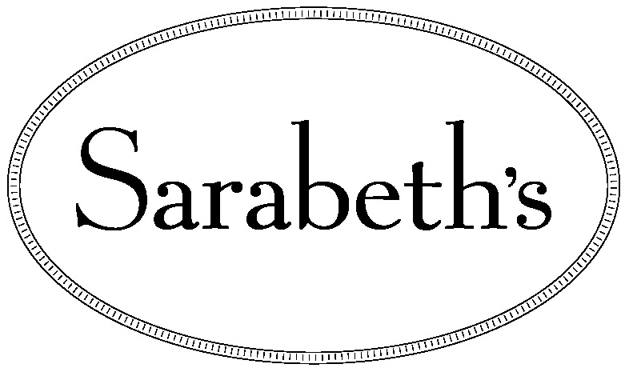

212-296-6280

www.sarabethsrestaurants.com

423 Amsterdam avenue

between 80th & 81st streets

new york, ny 10024